Template: Study Material
<CO5>: <22142>: <Java Programming>: <Applet Execution>: <UO2a>: <Study Material>
<Sneha Patange> | <7/2/2021> | <Vijay Patil>
Key words  Applet execution Using Applet viewer  Applet execution in Web browser | Learning Objective:  Student should understand how to run applet Using Applet viewer and web browser. | Diagram/ Picture
Key Questions  - Explain steps to execute applet using appletviewer  - Explain steps to execute applet using web browser  - Write a java applet code to execute a simple applet | Concept Map  Use insert smart art to draw a neat concept map – also connect the topic to other topics – so student realises why this LO is important  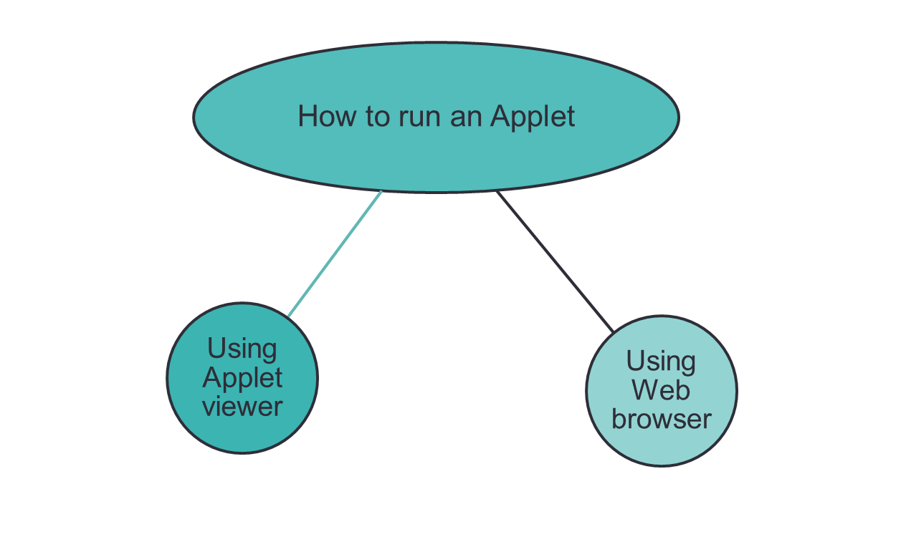

Explanation of concept:
- This applet begins with two import statements. The first imports the Abstract Window Toolkit (AWT) classes.
- The AWT contains support for a window-based, graphical user interface.
- The second import statement imports the applet package, which contains the class Applet. Every applet that you create must be a subclass of Applet.
- The next line in the program declares the class SimpleApplet. This class must be declared as public because it will be accessed by code that is outside the program.
- Inside SimpleApplet, paint( ) is declared. This method is defined by the AWT and must be overridden by the applet.
- paint( ) is called each time that the applet must redisplay its output. This situation can occur for several reasons. For example, the window in which the applet is running can be overwritten by another window and then uncovered. Or, the applet window can be minimized and then restored. paint( ) is also called when the applet begins execution. Whatever the cause, whenever the applet must redraw its output, paint( ) is called.
- The paint( ) method has one parameter of type Graphics. This parameter contains the graphics context, which describes the graphics environment in which the applet is running. This context is used whenever output to the applet is required.
- Inside paint( ) is a call to drawString( ), which is a member of the Graphics class. This method outputs a string beginning at the specified X,Y location. It has the following general form:

void drawString(String message, int x, int y)

Here, message is the string to be output beginning at x,y. In a Java window, the upper-left corner is location 0,0. The call to drawString( ) in the applet causes the message “A Simple Applet” to be displayed beginning at location 20,20.
- The applet does not have a main( ) method. Instead, an applet begins execution when the name of its class is passed to an applet viewer or to a network browser
Steps to run applet
- Steps to run an applet:
- Write a source code for an applet
- Save it with .java extension
- Compile applet source code
- Run an applet either using applet viewer or web browser
Two ways in which we can run an applet:

There are two ways in which we can run an applet:
- Executing the applet within a Java-compatible web browser.
- Using an applet viewer, such as the standard tool, appletviewer.
An applet viewer executes your applet in a window. This is generally the fastest and easiest way to test your applet.
- Running an applet in web browser
To execute an applet in a web browser,
We need to write a short HTML text file that contains a tag that loads the applet.
The APPLET tag is used for this purpose.
Here is the HTML file that executes SimpleApplet:
<applet code="SimpleApplet" width=200 height=60>
</applet>
The width and height statements specify the dimensions of the display area used by the applet
After creating this file, execute the browser and then load this file, which causes SimpleApplet to be executed.
To execute SimpleApplet with an applet viewer, For example, if the preceding HTML file is called RunApp.html, then the following command line will run SimpleApplet:
C:\>appletviewer RunApp.html
- Running an Applet Using AppletViewer

- This is more convenient method that can be used to speed up testing.
- It simply includes a comment at the head of Java source code file that contains the APPLET tag.

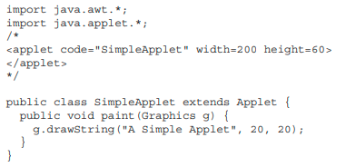
With this approach, we can quickly run an applet by using these three steps:

- Edit a Java source file.
- Compile your program.
- Execute the applet viewer, specifying the name of your applet’s source file.
appletviewer SimpleApplet. Java
The applet viewer will encounter the APPLET tag within the comment and execute an applet.

Solved word Problem
Explain execution of applet life cycle with help of example?

 | Application of Concept/ Examples in real life  OUTPUT:  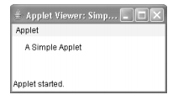 | Link to YouTube/ OER/ video  Link to any youtube that also explains either this concept or the application of this concept Open the link and then Insert the link here – Ctrl+K
Key Take away from this LO:
Concept of Java Applet

