Template: Study Material
Insert the details within the < quotes >
<COIF>: <22412>: <Java Programming>: <Managing Input/Output Files in Java>: <LO3>: <Study Material>
<Siddhesh Vaidya> | <01/02/2021> | <Vijay Patil>
Key words  Input Stream Classes | Learning Objective:  - Understand the concept of Output Stream Classes | Diagram/ Picture  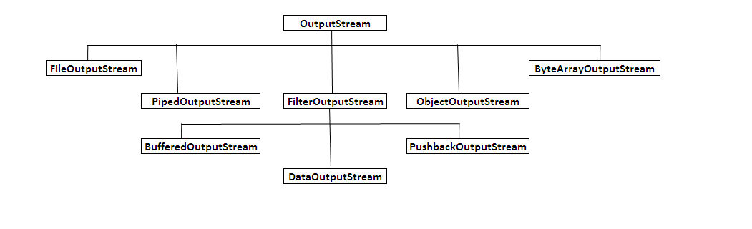
Key Questions  What is Output Stream? | Concept Map
 | Explanation of Output Stream Classes  - The java.io.OutputStream class sends raw bytes of data to a target such as the console or a network server.  - Like InputStream, OutputStream is an abstract class.  - The OutputStream includes methods that perform operations like:  - writing bytes  - closing streams  - flushing streams  Methods:  - void close() - to close the OutputStream  - void write (int b) - Writes a single byte to an output stream.  - void write(byte buffer[ ]) - Writes a complete array of bytes to an output stream.  - void write (byte buffer[ ], int offset, int numbytes) - Writes a sub range of numbytes bytes from the array buffer, beginning at buffer[offset].  - void flush() - clears the buffer. | Key Definitions/ Formulas  Output Streams
Classification of Output Streams
Can be classified as follows
 |  | Link: https://www.youtube.com/watch?v=_le5GlfBxVY
Key Take away from this LO: Understanding the Output stream classes, Classification and its methods

