Template: Study Material
Insert the details within the < quotes >
<CO>: <22412>: <Java Programming>: <Exception >: <LO1c>: <Study Material>
<Sushama Pawar> | <02/11/2020> | <Prof.Vijay Patil >
Key words  Exception, , | Learning Objective:  Students should distinguish the error and exception(if any ) in the given example. | Diagram/ Picture
Key Questions  Difference between error and exception | Concept Map  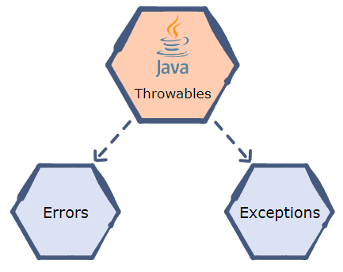
 | Both java.lang.Error and java.lang.Exception classes are sub classes of java.lang.Throwable class, but there exist some significant differences between them. java.lang.Error class represents the errors which are mainly caused by the environment in which application is running.  For example, OutOfMemoryError occurs when JVM runs out of memory or StackOverflowError occurs when stack overflows.  Where as java.lang.Exception class represents the exceptions which are mainly caused by the application itself.  For example, NullPointerException occurs when an application tries to access null object or ClassCastException occurs when an application tries to cast incompatible class types.  Sr. No. Exception Error  You can recover from exception by handling them through try catch block. It is impossible to recover from error  It is impossible to recover from error Exception can be classified into two types: - Checked Exception - Unchecked Exception There is no such classification for errors. Errors are always unchecked  Can occur at runtime or compile time due to an issue in the program Occur at runtime due to lack of system recourses.  Exceptions in java are of type java.lang.Exception. Errors in java are of type java.lang.Error  e.g. ArithematicException SQLException e.g. OutOfMempryError StackOverflowErro | Key Definitions/ Formulas  Errors are mistakes that can make program go wrong.
Solved word Problem
Write a program to demonstrate error in program?
Example: Incorrect format of selection statements or loops
class IncorrectLoop {
public static void main(String args[])
{

System.out.println("Multiplication Table of 7");
int a = 7, ans;
int i;

// Should have been
// for(i=1; i<=10; i++)
for (i = 1, i <= 10; i++) {
ans = a * i;
System.out.println(ans + "\n");
}
}
}

 | Application of Concept/ Examples in real life  The real life example of error is used when the frequency of occurrence of an exception cannot be predicted. | Link to YouTube/ OER/ video
Key Take away from this LO1c: Student should distinguish the error and exception(if any ) in the given example.

